Names:___________________________________ and ______________________________________________

Proportional

Problem Solving Connections – Proportional Reasoning

Car or Motorcycle? The table gives information on the world’s fastest car and fastest motorcycle. Suppose the car and motorcycle race for 10 minutes at the rates shown. Which vehicle would win the race (that is, which vehicle would travel farther)? What would be the margin of victory?

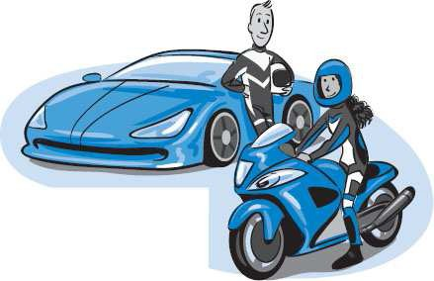

World’s Fastest Car and Motorcycle
Vehicle | Name | Time | Distance
Car | SSC Ultimate Aero | min | mi
Motorcycle | Suzuki Hayabusa | min | mi

Find Unit Rates

  - Find the speed of the car by calculating the unit rate. Show your work below.

  - Find the speed of the motorcycle by calculating the unit rate. Show your work below.

  - Which vehicle goes faster, the car or the motorcycle? How do you know?

Make Tables and Write Equations

- Complete the tables for the car and the motorcycle.

Car
Time (min) | 1 |  |  | 2 |  |  | 3 |  |  | 4 |  |  | 5
Distance (mi)

Motorcycle
Time (min) | 1 |  |  | 2 |  |  | 3 |  |  | 4 |  |  | 5
Distance (mi)

- Are the relationships in the tables proportional relationships? Why or why not?

- What is the constant of proportionality for the car?

What is the constant of proportionality for the motorcycle?

- How are the constants of proportionality related to the unit rates?

- Write an equation that gives the relationship between time and distance for the car. Tell what the variables represent.

- Write an equation that gives the relationship between time and distance for the motorcycle. Tell what the variables represent.

Make Graphs

- 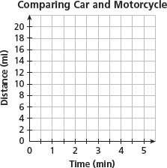Use your tables and/or your equations to graph the relationship for the car and the relationship for the motorcycle. Graph both relationships on the coordinate plane at right.

- How are the two graphs similar?

- How are the two graphs different?

- Do both graphs pass through the origin? Why does this make sense?

- Is it possible to tell which vehicle is faster just by glancing at the graphs? If so, how?

- How can you use the graphs to determine the winner of the race?

Answer the Question

- Explain how to find the distance each vehicle travels in 10 minutes using your tables.

- Explain how to find the distance each vehicle travels in 10 minutes using your equations.

- Complete the table to help you find the margin of victory.

Race Summary
Winner of race (circle one) | Car |  | Motorcycle
Loser of race (circle one) | Car |  | Motorcycle
Distance winner travels in 10 minutes
Distance loser travels in 10 minutes
Margin of victorys

- Extend the Ideas Speeds of cars and motorcycles are most familiar when they are written in miles per hour (mi/h). Use these tables and proportional reasoning to find the speed of each vehicle in miles per hour.

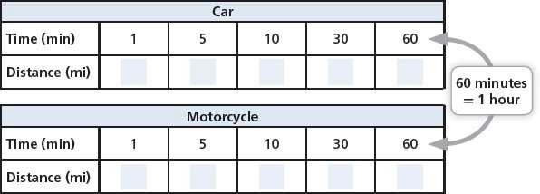

Speed of car: mi/h

Speed of motorcycle: mi/h

