Situation:

You are taking a taxi in Gotham City. The taxi fare in Gotham City is $2.50 for each mile driven. You also plan to give the driver a $5 tip. How many miles can you take a taxi if you have $25?

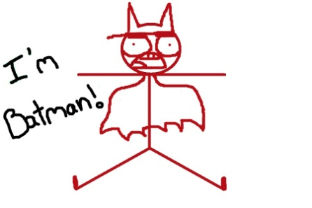
Step 1: What information is given in the situation?

$2.50 each mile driven
$5 tip
$25 total

Step2: Identify your unknown (what do you want to find?).
In mathematics we call this unknown the independent variable.
It doesn’t depend on any other numbers, and is what you need to find in order to answer your question.

x =

Step 3: Piecing it together as an equation.

Step 4: Evaluate your equation. Does your answer make sense?

You can ride 8 miles in the taxi.

Examples
1) An amusement park charges $1.50 per ride and an additional $10 to get in to the park. If you spent $22 at the amusement part, write and solve an equation that will determine how many rides you went on.
Step 1: What information is given in the situation?

Step2: Identify your unknown (what do you want to find?).

Step 3: Piecing it together.

Step 4: Evaluate your equation. Does your answer make sense?

2) The ages of three sisters are consecutive integers. The sum of their ages is 45. Calculate their ages.
Step 1: What information is given in the situation?
*Consecutive Integers (1, 2, 3)
*Sum =
Step2: Identify your unknown (what do you want to find?).

Step 3: Piecing it together.

Step 4: Evaluate your equation. Does your answer make sense?

Video 2
Example #1
- Aris buys some scarves that cost $5 each and 2 purses that cost $12 each. The cost of Aris’s total purchase is $39.

Write the equation to represent the situation. How many scarves did Aris buy?

Variable: __________________

Example #2
- Amber buys 3 bracelets and 3 necklaces. Each bracelet costs $5. Amber pays the clerk $40 and gets $4 change.

Write the equation to represent the situation. How much did each necklace cost?

Variable: __________________

Example #3
- Jerry exercised the same amount of time each day for 5 days last week.
  - His exercise included walking and swimming
  - Each day he exercised, he walked for 10 minutes.
  - He exercised for a total of 255 minutes last week.

Write the equation to represent the situation. What is the number of minutes Jerry swam each of the 5 days last week?

Variable: __________________

